Monday, 08 March 2021
This date corresponds to the celebration of the International Women's Day; to this end, the ITAKA Escolapios network has decided, and this is a first, to stop and say << THANK YOU>> !!!!
To whom?? Perhaps the theme will give us an answer;
THEME: << WOMEN OF ITAKA-ESCOLAPIOS >>
At the ITAKA headquarters of BAFIA, this theme was the subject of a round table discussion in the courtyard of the Calasanz school with the different groups of speakers:
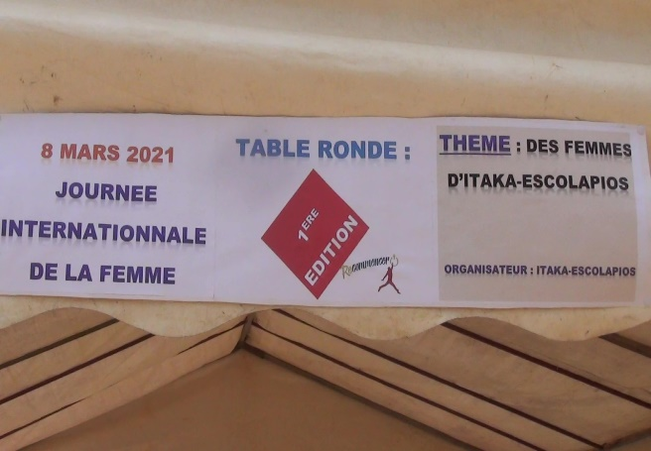
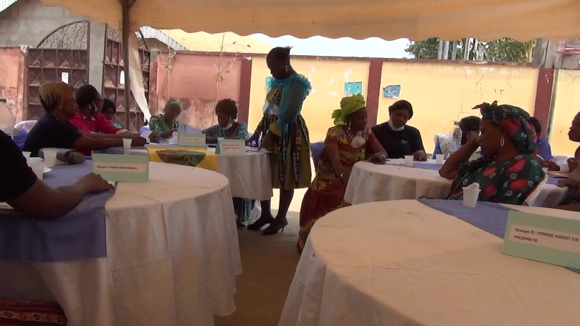
- Group A: WOMAN TEACHER Group B : WOMAN COOKER
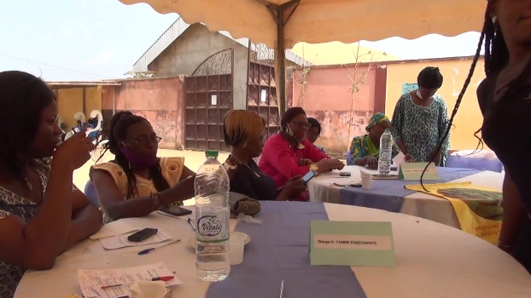
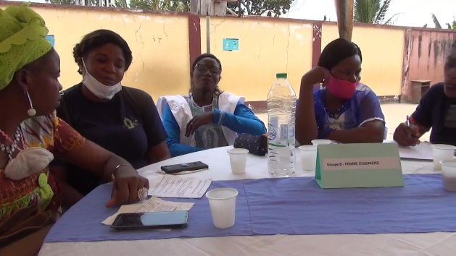
- Group C : CONSECRATED WOMAN Group D : WOMAN HOUSEKEEPER
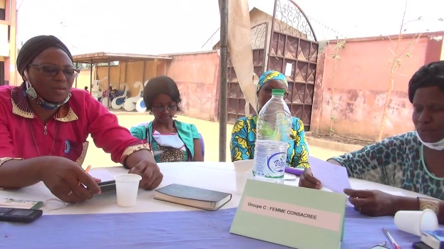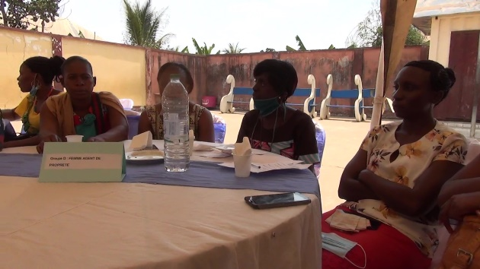
From the outset, the reflection on this theme was framed by the analysis of the theme in the form of 05 questions, which were debated during this round table:
- Which women around you participate or work at Itaka-Escolapios or at the order of pious schools?
All the groups of speakers consider that they work in the order of pious schools as teachers, cooks in the canteen, tutoring and catechesis for children and cleanliness of the children and the premises.
- What is their work? and do they correspond to tasks traditionally associated with women?
Teaching and educating, preparing the meal, giving catechesis and spiritual guidance to the children, ensuring the cleanliness of the school premises. The different opinions show that traditionally it is the woman who carries out these different tasks in society because of her closeness to the children, her natural physiology, the educational castes.
- Do you think that the work of these women is sufficiently recognised?
These women think that their work is not sufficiently recognised; firstly because of the pejorative conception that society has of the status of women and secondly because by her nature she gives herself more to those tasks that are already an integral part of them and which are attributed to her.
- Do they occupy senior positions or management teams?
The various interventions show that they occupy positions on management teams.
- What can we do to improve the situation of inequality of women that we are facing?
surround?
The WOMAN TEACHER, the WOMAN COOKER, the WOMAN DEDICATED, the WOMAN HOUSEHOLDER think it is important :
- To train the woman:
- Sensitize the woman
- Valuing women's work.
This round table was moderated by the local correspondent ITAKA of BAFIA.

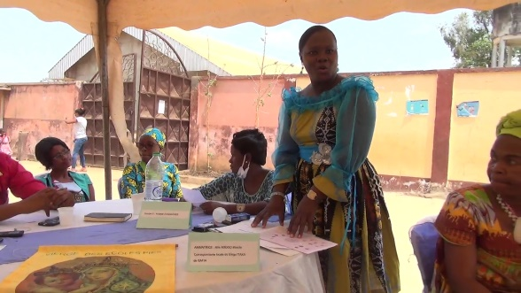
With the participation of the school director: Father Clément, the head office coordinator: Brother Justin Badin, the head of the socio-educational centre: Brother Dieudonné Kum, speakers and guests.
The day ended with a meal after a photo session.
